**Report for the Shropshire Gundog Society Committee**

**AV Retriever Novice & Open Working Test**

**Held on Sunday 12th May, 2024**

Shropshire Gundog Society held their Any Variety Retriever, Novice and Open Working Test on Sunday 12 May 2024 at the stunning new venue of Papermill Park, a simulated game, clay-shooting ground, near Moston, 9 miles North of Shrewsbury. The Club is most thankful to, to Sue and Bernie Hutchinson for inviting us to run our tests on their ground and for allowing us to use their excellent facilities, not least, all the benefits of a shooting lodge with ample parking. Sue also kindly put-up signs for parking and the exercise area. We were blessed with summer weather at last, which along with the beautiful Shropshire countryside provided a great setting for the event. An earlier date was deliberately planned this year after the extreme heat experienced in June 2023, but it seems that hot days coincide with SGS test dates!

Our four judges for the day were John Yarwood (A Panel), Dawn Scott (B Panel), Gary McCarthy and Chris Kettle who with Chief Steward Dr Malcolm Awty, provided an excellent series of Tests over varied ground including a challenging water series. Thanks to Malcolm for making the Judges’ work easier with very few adjustments needed. The only major change was for the Open water test that had to be moved due to a mother Coot building a nest and laying eggs at the entry point into water! It was unfortunate that competitor numbers were down a little this year, but this has been the trend in some regions. Several bitches in season were withdrawn in the week prior to the test and one of the Clubs regular competitors messaged the day before to say she has Covid. There were 27 Novice entries on the Card and 25 ran on the day while we had 16 runners in the open.

Sincere thanks to the stalwarts on the Committee who came and stood in the sun as Stewards, dummy placers, shot firers and contributing to the organisation and to Jayne CB for the cakes. Also, thanks to those competitors who assisted during the day. Cindy Joule’s granddaughter Maisie deserves a special mention for working a as a dummy placer both morning and afternoon and helping to sell raffle tickets. My particular thanks go to Grace and Chris who are always there to ‘get it done’; putting extra signs out, bringing and setting up hot and cold beverages, arranging all the food and gifts for officials and helpers and looking after the ‘office’. Grace also chases down the Judges for their scores and within a few minutes we have results printed and winner’s certificates being prepared. We were also fortunate to have several new helpers who were familiar with the ground, being involved with the Acton Reynald Estate Shoot that borders Papermill Park and hope that they enjoyed their day, and we will see them back again.

Thanks to our sponsors, Skinner's for their on-going support of SGS events and this year we have a more formal relationship with Sporting Saint who provided prizes for dogs placed in the Novice and Open Retriever Test in addition to their excellent support for the Spaniel Training and Field Trials. The Raffle raised £101 for Midlands Air Ambulance which was a great effort given the lower number of participants.

By the end of the morning four dogs had been placed in the Novice Stake:

1st Paul Edmunds and Myndydddu Iceman: Trophy Challenge Cup

2nd Brian Jones and Astraglen Jamie; Presidents award for Judges Choice

3rd Steve Newitt and Quingrave Meg

4th Anna Hopley and Lady of Balterly Wood at Hopleamede

*Novice Test Winners L-R: Steve Newitt, Sue Hutchinson (MD of Papermill Park), Paul Edmunds, Bian Jones, Anna Hopley*

In the afternoon, after four challenging Open tests, only three dogs were placed, and judges expressed some disappointment that they could not find a ‘Judges’ Choice’. The hot weather made conditions tough for the dogs.

1st George Davies and Sorrelcott Superior; Silverdown Cup

2nd Steve Newitt and Castletioram Caledonia at Quingrave;

3rd Shane Gilliver and Slingley Black Beauty at Minerskiln.

*Open Test Winners* *L-R: Chris Kettle (Judge), Shane Gilliver, Sue Hutchinson, George Davies, Dawn Scott (Judge), Steve Newitt, Gary McCarthy (Judge) John Yarwood (Judge)*

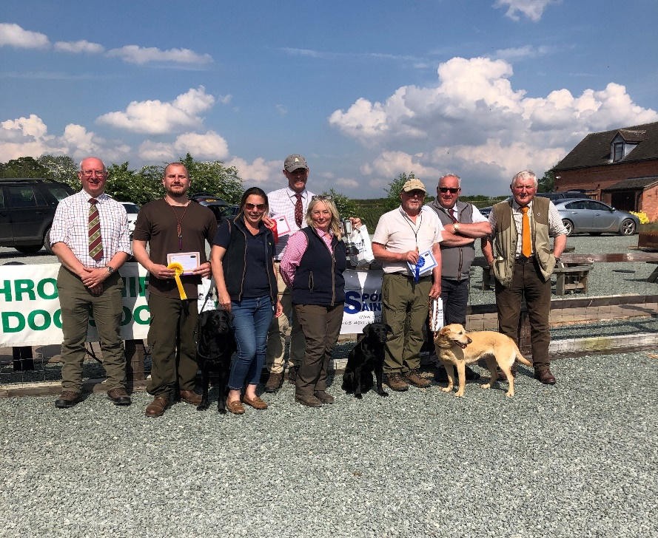

No awards for AV Retriever (Non-Lab) this year although it was nice to see a Nova Scotia Duck Tolling Retriever running and a lovely Flatcoated Retriever that was unlucky not to be in the awards.

Both Judges and competitors commented on how good the venue and the facilities were, so we propose to book a similar date at the same venue for next year. The Hutchinsons are keen to expand their business to include dog training groups and have already received expressions of interest following the SGS Working Test. This may also provide an opportunity for SGS to hold other events at Papermill Park in the future.